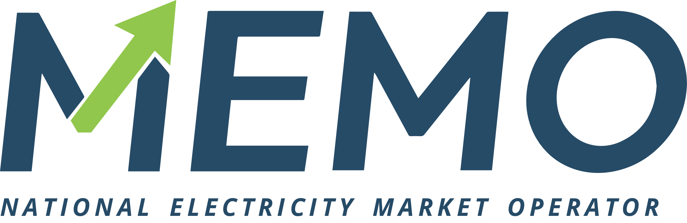

Application form for participating on the organized electricity market – Day ahead segment

Introduction and filing address
MEMO Ltd Skopje operates the day ahead electricity market and respective trading and clearing systems in accordance with the Rules for Operation of the Organized Electricity Market (hereinafter referred to as “Rules”). This application form (hereinafter "Application") is the form required in accordance with the Rules for the application for organized electricity market participation and it should be duly signed and submitted together with the necessary documentation. The Application is submitted to:
OEMO – National electricity market operator- MEMO Ltd Skopje
Str. Maksim Gorki No.4
City: Skopje
Country: Republic of North Macedonia
Phone: + 389 2 314 9 023
E-mail: membership@memo.mk

Application
We, (the Applicant), are hereby applying for day ahead market participation as:
☒ Direct Market Member
☐ Indirect Market Member
Depending on the choice of the type of participant, the amount of fees for participating in the organized electricity market is different. We are looking to be a:
☒ Type A Market Member
☐ Type B Market Member

Applicant’s Identification Data

Official company name
Full company name
Short company name
Legal Status/License type
Identification number
Place of registration
Address
City, Post No.
Country
VAT Number
EIC Identification Code
Bank Information
Name of applicant’s Bank
Address of the applicant’s bank
SWIFT Code
Account number

Obligatory attachments checklist

The following documents, save for the documents that have already been conveyed to the electricity market operator during previous admission processes (bilateral market), shall be filed with the Application for admission:
- Status from the official company registry stating the latest facts not older than 30 days. (Mandatory if there are changes in the status from previously filled in the process of registration on the bilateral market)
- Copy of the license to perform energy activities in North Macedonia issued by NRA. (Not applicable for eligible consumers)
- Copies of the official documents confirming the applicant’s tax registration numbers stated in the Application for Admission.
- Nomination sheet duly signed.

Statements and Signatures

We, (Applicant) and (Nominate persons) hereby state and assure and give consent respectively that we:
- are commercially engaged in the business of either buying and selling of electricity;
- are familiar with and accept the Rules without reservations.
- shall acknowledge and observe the Rules including future amendments.
- shall always fulfill all obligations towards the OEMO and other market participants, in accordance with the Rules and applicable laws and with respect to the risk exposure, originating from our activities on the day ahead electricity market.
- have all necessary authorizations and permissions required by applicable laws in order to do business and trade on the day ahead electricity market.
- possess all the necessary skills to perform duties in accordance with the Rules and regulations of OEMO.
- Especially understand the volatile nature of performing activities on the day ahead electricity market and accept the risks arising from it.
- Will forward to OEMO all documents that may help OEMO to identify a violation of Rules and regulations.
- Without undue delay notify OEMO of all changes of a factual or legal nature in relation to the information and data requested and/or submitted during the registration process.
- Agree for OEMO to publish our company as Market Member upon admission.
Agreed and signed on (date)

Company name: | ________________________________________
Authorized signatory: | ________________________________________
Signature: | ________________________________________

Nomination sheet
We, (Company name) hereby nominate the persons stated below as Applicant’s Trading and Clearing Representatives to be approved by OEMO as such:

Trading representatives authorized to act on Applicant’s behalf.
 | Name | Surname | Telephone | E-mail | Date of birth | Place of birth
1
2
3

Clearing representatives authorized to act on Applicant’s behalf.
 | Name | Surname | Telephone | E-mail | Date of birth | Place of birth
1
2
3

IT support
Contact to send ETS login and password
IT Contact name
IT Contact phone
IT Contact e-mail

Statement
We, (Company name) a Market Member on the organized electricity market in the day ahead segment shall upon decision to withdraw authorization of any of the persons promptly inform OEMO of such decision in writing using the appropriate forms. OEMO shall, upon receipt of the aforementioned information on withdrawal of authorizations, effect the changes in authorizations within its Trading System and Clearing System without undue delay. Until information on withdrawal of authorizations is received by OEMO and the time needed to effect the appropriate changes in the Trading system and/or Clearing system passes, the authorizations shall be deemed as valid in relation to OEMO and other market members.

<
Date of statement:
Authorized signatory:
Signature:

